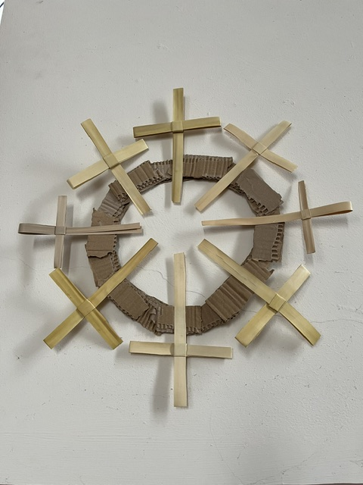

St James Episcopal Church Muthill

www.stjamesmuthill.com

Sunday 21st June 2026
Evening Service
Do stay for refreshments after the service

THIS SUNDAY 21st JUNE 5.30pm Evening Service led by Canon Richard Grosse
NEXT SUNDAY 28th JUNE 5.30pm Evening Service led by Rev’d Jim Newell (Auchterarder United Free Church, formerly from Crieff Baptist Church)

SUNDAY 5th JULY 5.30pm Service of Holy Communion, led by Rev’d Charles Sherlock
SUNDAY 12th JULY 5.30pm, Evening Service led by Rev’d Ross Stirling-Young (Curate at St Columba’s Episcopal Church Stanley & Perth Cathedral)
SUNDAY 19th JULY 5.30pm, Evening Service
SUNDAY 26th JULY 5.30pm, Evening Service
SUNDAY 2nd AUGUST 5.30pm, Service of Holy Communion

Muthill Primary School Prizegiving service last Wednesday at St James Church was well supported by school parents and friends. Thanks to those church members who helped with this event. We pray for all the school leavers and for all young families in Muthill and beyond.

FORTHCOMING EVENTS
Muthill Gala Week 20 – 28 June, events including car treasure hunt, whisky tasting, bowling, badminton, scarecrow displays.
Muthill Gala Sunday 28th June, 1pm onwards, Fancy dress parade, stalls, raffle, activities
Wednesdays at Muthill Parish Church, 11am for coffee, tea and biscuits in North Lounge (no lunches)
Saturday 8th August 12 noon, Induction of Rev’d Rachael Wright at St. James Church followed by Reception in the Bruce Hall, Muthill Parish Church. Do invite your friends and neighbours.
Thursday 27th August Memorial Service for Sarah Atkinson at St James Church
Saturday 26 & Sunday 27 September St James Church Open Doors Weekend

Open Doors Weekend 26 & 27 September. We will be displaying old photos and artefacts from our church and from Muthill – if you have any to share, please look them out to bring along. Recollections welcome too! If you’re interested in contributing ideas, time, floral displays or historic items, please contact Harriet.

In our prayers: Rev’d Rachael Wright and her family, our church members recovering from operations and those who care for loved ones, our civil and church leaders and for those in government.

First contact for St James Church: Alasdair Coates stjamesmuthill@gmail.com

