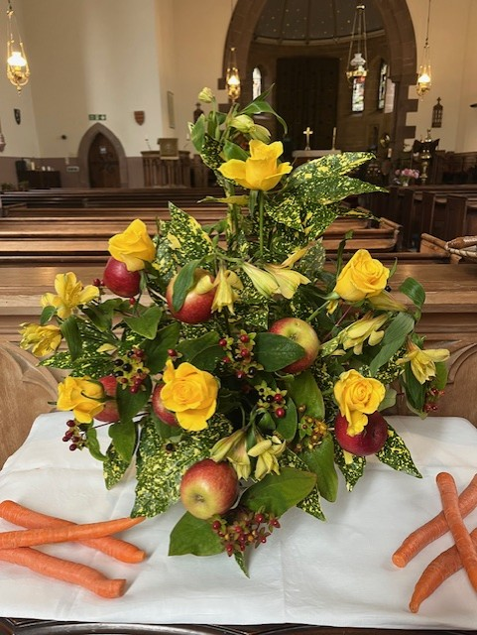

St James Episcopal Church Muthill

www.stjamesmuthill.com

Sunday 20th September 2026

Image: Harvest display, Muthill

Do stay for refreshments after the service
OUR REGULAR SERVICES
Sunday evenings at 5.30 pm – Evening Service
First Sunday of each month at 5.30pm Holy Communion Service
At Wardside House care home, Station Road, Muthill, last Sunday of each month at 2.30pm, a service of
Holy Communion to which all are invited.
Season of Creation If you have any favourite creation or harvest-themed hymns please let Rachael know, or add them to the list at the back of church.
FORTHCOMING EVENTS
Tuesday 29 September at 10.30am Vestry meeting at King’s Cottage, Balloch
Thursday 1st October at 12 30pm at St Kessog’s Garden, Auchterarder “When I am among the trees” – meditations on all that trees can teach us with poetry and prayer. Do dress for the weather.
Saturday 3rd October 9.30 to 11.30am Preparing and decorating the church for Harvest Festival
Sunday 4th October 5.30pm Harvest Festival service with Holy Communion at St James Church. Do come along and invite friends and neighbours.
Sunday 11th October at 3pm, Glen Artney Church Harvest Thanksgiving service, Dalchruin, Crieff PH6 2JQ. Service conducted by Muthill Parish Church. All very welcome
Tuesday 20th – Wednesday 21st October Hope for Creation Conference. Organized by the Scottish Episcopal Net Zero team to tackle climate change in the Scottish Church context. All are welcome, contact Rachael for more details.
Sunday 25th October, 10am – 2pm Classic Car and Bike Show with classic tractors, presented as fundraiser by Bertie Bus. Venue: North Dowald, off Highlandman Loan, Crieff PH7 3QU. £3 entry, light refreshments.

A BIG THANKS to all who support our church services by coming early to prepare, bringing refreshments, serving tea, printing notices, decorating with flowers, washing up and giving generously each week.

In our prayers: Jean Mackenzie, her sons Duncan and Euan and family; those among us who are ill or in trouble, our young families. And pray for Rachael and her ministry among us.

Priest-in-Charge Rev’d Rachael Wright 07510 687491 rev.rachaelwright@gmail.com
Usual days off: Friday and Saturday

Contact for St James Church: Alasdair Coates stjamesmuthill@gmail.com

