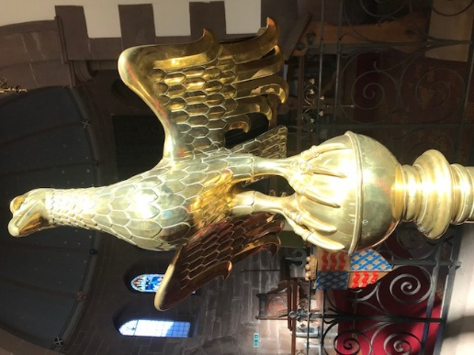

St James Episcopal Church, Muthill

www.stjamesmuthill.com

Epiphany
Sunday 4th January 2026

THIS SUNDAY 5.30pm Service of Holy Communion

NEXT SUNDAY 11th January
5.30pm Evening service (briefly) incorporating Church AGM – be sure to come and hear all about our year.

FORTHCOMING EVENTS
Every Wednesday 11am for coffee, tea and biscuits, then 12 for 12.30 prompt Soup and sandwich lunch at Muthill Parish Church

Sunday 4 January 1pm, Funeral of Helen Holland in St James Church
Sunday 11th January 5.30pm, Evening Service incorporating St James Church AGM
Monday 12th January, 7pm prompt, St James Church Film Night at Muthill Parish Church
Sunday 25th January 5.30pm Duncan’s last service.
Saturday 31 January 10am to 3.30pm, Net Zero Roadshow at St Ninian’s Cathedral Perth. Vegan lunch.
St Andrews, Dunkeld & Dunblane Net Zero Roadshow: Rescheduled – Net Zero Portal
Monday 2nd February 11.30 am, service of celebration for the life of Prue Kennard at St Kessog’s Church, High Street, Auchterarder.
Monday 9 February 7pm St James Film Night at Muthill Parish Church
Monday 9 March 7pm St James Film Night at Muthill Parish Church

Film Nights will be restarting in January, the first one will be on Monday 12th January at 7pm in Muthill Parish Church. Everyone is welcome to attend, from both churches, the Village and beyond. Free entry.

Let us pray for among us who are so recently bereaved; those for whom 2026 holds no promise of good things; those undergoing treatment or awaiting operations. Pray for Duncan and Katrina as they prepare to leave us and plan their retirement.
** If you would like your name on our newsletter prayer list, or would like prayers offered privately, please let Alasdair know on 07764 332400 or stjamesmuthill@gmail.com. Confidentiality is maintained.

Rector: Reverend Duncan Strathie 01764 662525 rector.auchterarder@gmail.com

