St James Episcopal Church, Muthill

www.stjamesmuthill.com

Sunday 1st February 2026
Presentation of Christ in the Temple

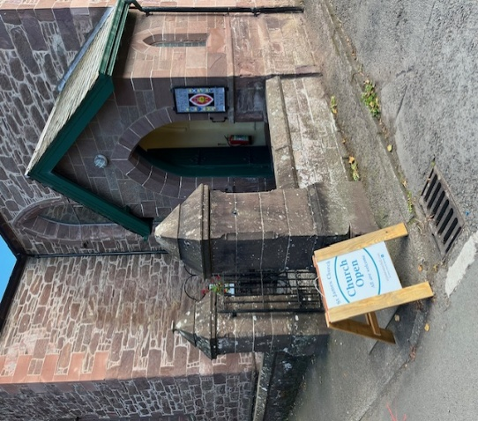

THIS SUNDAY 5.30pm Service of Holy Communion, led by Rev. Charles Sherlock
NEXT SUNDAY 8th February 5.30pm Service of Evening Prayer, led by Alasdair Coates
Sunday 15th February 5.30pm Evening Service, Dean Graham Taylor invited to lead
Sunday 22nd February 5.30pm Evening Service, led by Father Giles Dove
Sunday 1st March 5.30pm Service of Holy Communion, led by Rev. Charles Sherlock

FORTHCOMING EVENTS
Every Wednesday 11am for coffee, tea and biscuits, then 12 for 12.30 prompt Soup and sandwich lunch at Muthill Parish Church
Monday 9th February 7pm prompt St James Film Night at Muthill Parish Church
Monday 9th March 7pm prompt St James Film Night at Muthill Parish Church
Sunday 3rd May 5.30pm Special service of Choral Evensong, led by Bishop Ian and with the choir of St Ninian’s Cathedral, Perth.
Monday 21st to Sunday 28th June Muthill Gala Week – including St James Anniversary events

Duncan’s Farewell and our future A big thank you to all who helped make Duncan’s retirement a special and memorable occasionMeanwhile, negotiations and discussions are continuing with the Vestry of St Kessog’s Church, Auchterarder, with whom we share the Rector (and costs) and with Bishop Ian, to begin the process of recruiting a new Rector (freehold) or Priest in Charge (contracted for a specific term). Do pray for the right candidate!

PATRONAL FESTIVAL, Sunday 3rd May 2026 This year, as part of our 190th Anniversary Celebrations, we are celebrating the festival of St James The Less, our Patron, with a special service and other activities. Speak to Harriet if you’d like to contribute time and ideas.

Let us pray for our Vestry team, those in hospital or awaiting treatment, political leaders

** If you would like your name on our newsletter prayer list, or would like prayers offered privately, please let Alasdair know on 07764 332400 or stjamesmuthill@gmail.com. Confidentiality is maintained.

Current contact for St James Church: Alasdair Coates stjamesmuthill@gmail.com

